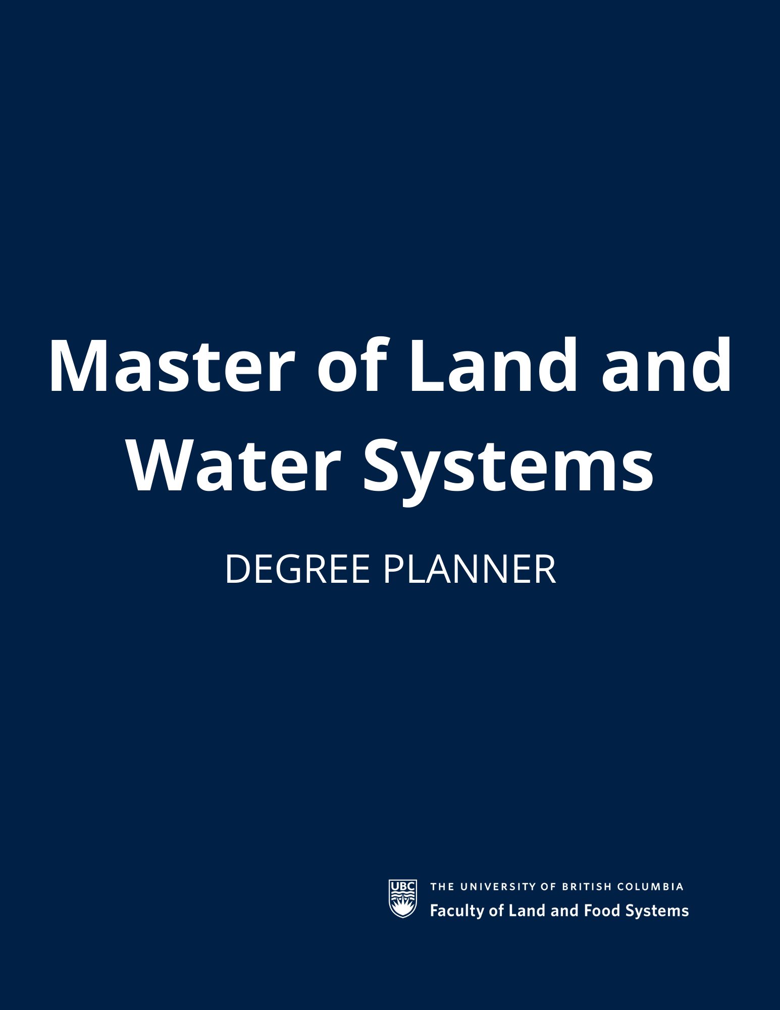
Table of Contents

Personal Information 3
Program information 3
How to use this degree planner 3
Degree summary 3
Requirements 4
First Year 4
Second Year 5
Third and Fourth Year 6
Additional Resources 8

Personal Information
Name:
Student No.:
Email Address:

Program information
Degree: Master of Land and Water Systems
Program: Land and Water Systems
Program Advisor:

How to use this degree planneR

Degree summary

Requirements | Minimum | Taken
Total Credits | 33
Required Credits | 21
Elective Credits | 12

Requirements

Winter TERM 1 (September – December)
Courses | Academic Term | Credits
LWS 501 – Advanced Soil Processes |  | 3
LWS 510 – Land and Water Seminar Series | 1-2 | 3
AT LEAST ONE OF:  LWS 515 – Watershed Science  OR:  LWS 517 – Land and Water Resources Evaluation |  | 3
Program electives *
 |  | 3
 |  | 3
TOTAL (First Term) |  | 15

*Note: Not all elective courses listed on the MLWS website are offered every academic year. We try to keep our website up to date but double-check the UBC Course Calendar to see if the course is offered during the duration of your program. Check that you have course prerequisites or equivalents. Other courses may be substituted with the permission of the MLWS Academic Coordinator. To register for courses, visit the UBC Student Service Centre (SSC).
**Of the 33 course credits, 6 credits (1 elective course + required course FRE 302) may be at the 300 – 400 level, and 27 credits must be at the 500 – level or higher.
***If you decide to take both LWS 515 and LWS 517, one will count as an elective. Please add it to the elective box in the table above.

Winter TERM 2 (January – april)
Courses | Academic Term | Credits
LWS 510 – Land and Water Seminar Series | 1-2 | -
LWS 550 – Professional Communication Strategies | 2 | 3
FRE 302 – Small Business Management | 2 | 3
Program Electives
 |  | 3
 |  | 3
TOTAL (Second Term) |  | 12

Summer Term (May – August)
Courses | Academic Term | Credits
LWS 548 – Major Project * | 1-2 | 6
TOTAL (Summer Term) |  | 6

* Components of LWS 548 will be addressed throughout Winter Term 1 and Winter Term 2.

Additional Resources
Courses: https://mlws.landfood.ubc.ca/program-overview/courses/
Calendar MLWS page: http://www.calendar.ubc.ca/vancouver/index.cfm?tree=14,266,773,1450
UBC SSC Courses: https://courses.students.ubc.ca/cs/courseschedule?pname=subjarea&tname=subj-all-departments

